9.A college has more than thousand security persons, who are instructed to give duties at
different places within the campus. Additionally, they also maintain a routine, which
contains all information, such as Date, Duty Start Time, Duty End Time, and Place.
Most importantly, all the places are covered by at least one security person. If a security
person takes leave, manual entry is done against that person. Finally, at the end of a
month, the security persons get paid for their duties, while considering the number of
leaves as well. You can see that the manual calculation/operation is a heavy task for the
security manager. Therefore, the objective is to build an Online security management
system using class diagram through which entire security system within the campus can
be controlled in an efficient manner

AIM:

To design a class diagram for an online security management system for a college campus.

PROCEDURE:

Identify Actors:
- Security Manager: Assigns duties and manages security personnel.
- Security Personnel: Perform assigned duties and report incidents.
- System: Tracks duty schedules, attendance, and salary calculations.
Define Classes:
- Duty Schedule: Stores security personnel assignments, including date, time, and location.
- Leave Management: Tracks security personnel leave requests and approvals.
- Payment Calculation: Computes salaries based on worked hours and leaves taken.
Create Diagrams:
- Class Diagram: Defines relationships between security personnel, duty schedules, leave records, and payroll management.

DIAGRAM:

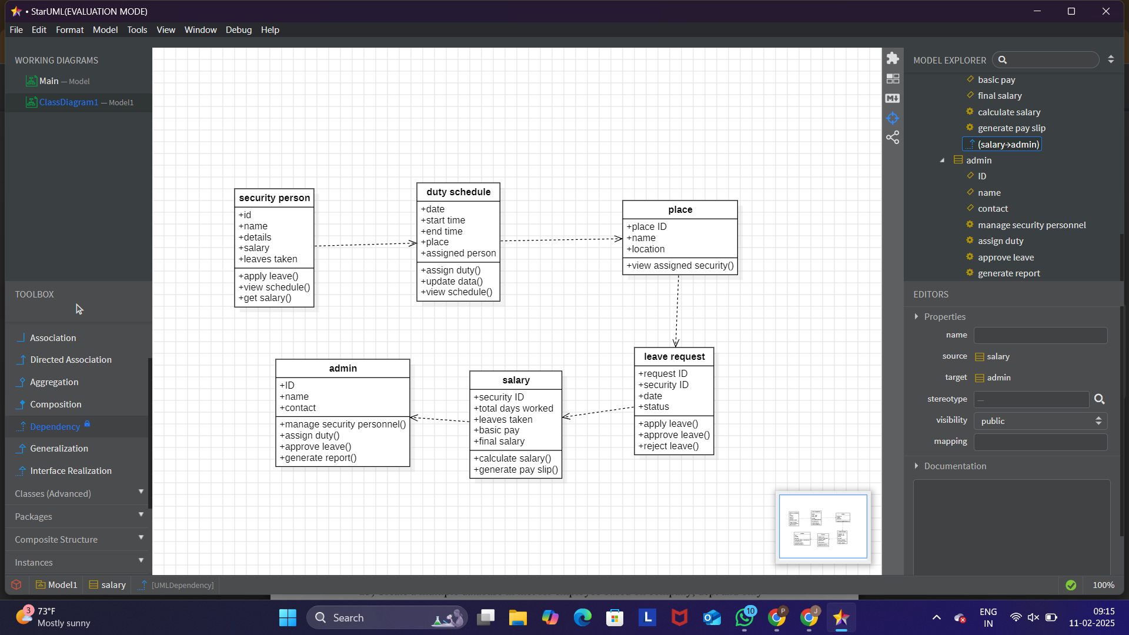

RESULT:

The UML diagram provides a structured framework for managing security personnel efficiently, improving duty assignment, attendance tracking, and payroll calculations.

